**VIETNAM NATIONAL UNIVERSITY OF HO CHI MINH CITY**

**THE INTERNATIONAL UNIVERSITY**

**SCHOOL OF COMPUTER SCIENCE AND ENGINEERING**



**A WEB APPLICATION for**

**ADMINISTRATIVE Document**

**DIGITIZATION**

**By**

**VŨ NHẬT THANH**

**A THESIS SUBMITTED TO THE SCHOOL OF COMPUTER SCIENCE AND ENGINEERING**

**IN PARTIAL FULFILLMENT OF THE REQUIREMENTS FOR THE DEGREE OF BACHELOR OF**

**COMPUTER SCIENCE**

Ho Chi Minh City, Vietnam

07/2020

**A web application for**

**administrative Document DIGITIZATION**

|  |  |
| --- | --- |
| aPPROVED BY ADVISOR | aPPROVED BY committee |
|  | ______________________ |
|  | ______________________ |
|  | ______________________ |
|  | ______________________ |
| ______________________ | ______________________ |
| Nguyen Van Sinh, Ph.D. | Thesis Committee |

# ACKNOWLEDGMENTS

This is a good chance to express my gratitude to everyone who supported me. I am very grateful for the guidance and advice that they gave me during this thesis project.

Firstly, I would like to express my sincere appreciation to Dr. Nguyen Van Sinh, my supervisor for his guidance, suggestion, and patience during the Thesis development. His constant encouragement and support helped me so much to achieve this goal.

Next, I would like to thank my parents who gave me a chance to study at this school. They are always by my side when all the difficult things come to me. They help me stand up to complete this road.

Last but not least, I want to give my thanks to all of my friends at the International University for all the support and good memories that you gave me when we studied together.

**TABLE OF CONTENTS**

**ACKNOWLEDGMENTS** 3

**LIST OF FIGURES** 6

**LIST OF TABLES** 8

**ABBREVIATIONS** 9

**ABSTRACT** 10

**CHAPTER 1** 11

**INTRODUCTION** 11

**1.1** **Background** 11

**1.2** **Problem statement** 11

**1.3** **Scope and objectives** 11

**1.4** **Structure of the thesis** 13

**CHAPTER 2** 14

**BACKGROUND DESCRIPTION** 14

2.1 NodeJS and Express [1] 14

2.2 ReactJS [3] 15

2.3 MongoDB [4] 15

2.4 Docx library [5] 16

2.5 OpenCV [6] 16

2.6 Tesseract OCR [7] 17

2.7 Existing document digitization application 18

**CHAPTER 3** 19

**METHODOLOGY** 19

3.1 Overview 19

3.2 Proposed method for the conversion process 19

3.3 System architecture 22

3.4 User requirement analysis 23

3.5 Front-end 29

3.6 System design 40

**3.6.1** **Database Schema** 40

**3.6.2** **Class Diagram** 41

**3.6.3** **Graphical user interfaces** 42

**CHAPTER 4** 44

**IMPLEMENTATION AND RESULTS** 44

4.1 Implementation 44

4.2 Results 49

**CHAPTER 5** 56

**EVALUATION AND DISCUSSION** 56

5.1 Evaluation 56

5.2 Discussion 58

**CHAPTER 6** 59

**CONCLUSIONS AND FUTURE WORK** 59

6.1 Conclusions 59

6.2 Future work 59

**REFERENCES** 60

# LIST OF FIGURES

Figure 1.2: A structure of the document 12

Figure 1.3: Structure of the Thesis 13

Figure 2.1: The concept of NodeJS 14

Figure 2.2: Tesseract workflow 17

Figure 2.3: VietOCR Interface 18

Figure 2.4: Homepage of Legal Normative Documents 19

Figure 3.1: The result of each image processing step 22

Figure 3.2: The two detected areas 23

Figure 3.4: System structure 25

Figure 3.3: Use case diagram 26

Figure 3.5: Package of the project 34

Figure 3.6: Activity diagram for Create New Document function 34

Figure 3.7: Sequence diagram for Create New Document function 35

Figure 3.8: Activity diagram for Convert Document function 35

Figure 3.9: Sequence diagram for Convert Document function 36

Figure 3.10: Activity diagram for Find function 37

Figure 3.11: Sequence diagram for Find function 37

Figure 3.12: Activity diagram for Preview function 37

Figure 3.13: Sequence diagram for Preview function 38

Figure 3.14: Activity diagram for Edit function 38

Figure 3.15: Sequence diagram for Edit function 39

Figure 3.16: Activity diagram for Remove function 39

Figure 3.17: Sequence diagram for Remove function 40

Figure 3.18: Activity diagram for Export function 40

Figure 3.19: Sequence diagram for Export function 41

Figure 3.20: Activity diagram for Create User function 41

Figure 3.21: Sequence diagram for Create User function 42

Figure 3.22: Activity diagram for Change User Password function 43

Figure 3.23: Sequence diagram for Change User Password function 43

Figure 3.24: Activity diagram for Remove User function 44

Figure 3.25: Sequence diagram for Remove User function 44

Figure 3.26: Models of the database 45

Figure 3.27: User Interface of the Database page 46

Figure 3.28: User Interface of the Create Document page 47

Figure 3.29: User Interface of the User Management page 47

Figure 4.1: Project structure 48

Figure 4.2: Connecting to server 48

Figure 4.3: Checking the authentication 49

Figure 4.4: Handling RESTful API 49

Figure 4.5: Login component 51

Figure 4.6: Create New Document component 51

Figure 4.7: Create New Document component after the Conversion process 52

Figure 4.8: Document saving confirm dialog 52

Figure 4.9: User Management component 53

Figure 4.10: Database component 53

Figure 4.11: Preview modal 54

Figure 4.12: Edit modal 55

Figure 4.13: An exported DOC file 56

# LIST OF TABLES

Table 3.1: Use case description for UC-1: Create New Document 29

Table 3.2: Use case description for UC-2: Create Conversion Document 30

Table 3.3: Use case description for UC-3: Edit Document 30

Table 3.4: Use case description for UC-4: Remove Document 31

Table 3.5: Use case description for UC-5: Find Document 32

Table 3.6: Use case description for UC-6: Preview Document 32

Table 3.7: Use case description for UC-7: Export Document 33

Table 3.8: Use case description for UC-8: Create User 33

Table 3.9: Use case description for UC-9: Change User Password 34

Table 3.10: Use case description for UC-10: Remove User 34

Table 3.11: Requirement Analysis 35

Table 5.1: Accuracy and performance comparison 60

# ABBREVIATIONS

API: Application Programming Interface

ASCII: American Standard Code for Information Interchange

CL: Computer Language

CPU: Central Processing Unit

CSS: Cascading Style Sheets

CV: Computer Vision

DB: Database

DOC: Document

DPI: Dots Per Inch

GPU: Graphics Processing Unit

GUI: Graphical User Interface

HTTP:Hypertext Transfer Protocol

JPG: Joint Photographic Experts Group

JS: JavaScript

JSON: JavaScript Object Notation

MIT: Massachusetts Institute of Technology

MVC: Model-View-Controller

NPM: Node Package Manager

OCR: Optical Character Recognition

PDF: Portable Document Format

PNG: Portable Network Graphics

PSM: Page Segmentation Method

RAM: Random Access Memory

SQL: Structured Query Language

TS: TypeScript

URL: Uniform Resource Locator

XML: Extensible Markup Language

# ABSTRACT

Document digitization is one of the emerging trends of digitization and no more a new concept in the information science field. The digitization of documents allows retrieving of information from a paper document. The document digitization process involves conversion processing of the obtained image to extract information. The digitized document can be directly applied to searching, sorting, and storage stage. As the digitization literature is surveyed, the process of extraction of digital string from scanned paper documents plays a very important role in the document digitization process.

In this thesis, we will research and create an implementation application for processing the administrative documents, which used for management storing and searching. This application will focus on processing and digitizing the document. The method consists of the following steps: Obtaining data by using a scanner to scan administrative documents. Processing obtained data to remove noise and adjust the information, the content of the document is necessary. Finally, the application picks up the data based on the structure of documents following the criteria of the Vietnam government.

# CHAPTER 1

# INTRODUCTION

* 1. **Background**

Digitization of documents is the method of changing data within the document into a digital format. In this format, information is organized into discrete units of data that can be separately addressed. This is the kind of data that a computer can understand and process. The document can be digitized by the following steps: a scanner captures a document and converts it to an image file. An optical character recognition engine analyzes the light and dark areas to identify every single letter or digit and converts it into an ASCII code. After that, these codes will go through a process of analyzing and grouping into many small parts that can be stored for later use.

* 1. **Problem statement**

With the development of information technology, people are becoming more and more familiar with the utility that digital technology brings us. It leads to the fact that today's traditional documents cannot process to meet the demands of working time and space. Some surveys show that a typical employee spent half of working time to organize, store, and keep documents in the cabinet. These tasks wasted a lot of time and space to maintain a risk of losing documents.

To carry out these problems, an application in computer-based needs to be created to process all traditional documents into a digital document system. In this system, the documents are organized in a data structure to serve the professional task of administrative staff. Therefore it can help to keep information on the organization, easy to use for every people.

* 1. **Scope and objectives**

The objective of this thesis is to build a web application for Administrative Document Digitization. The thesis provides a tool that helps organizations to manage administrative documents by scanning and digitizing all of them, which can help to handle processing, maintaining, and finding documents easily. Also, it provides an ability for users to export the document in a printable format for use.

The input data are scanned Vietnamese administrative documents including NGHỊ QUYẾT, THÔNG BÁO, QUYẾT ĐỊNH, KẾ HOẠCH and CÔNG VĂN with the DPI over 300. Their structure has the following form:



Figure 1.0‑1: A structure of document

Document digitization project covers many problems. To reduce the amount of work, a good choice is to learn how to use and combine the existing library and framework related to this project.

* 1. **Structure of the thesis**

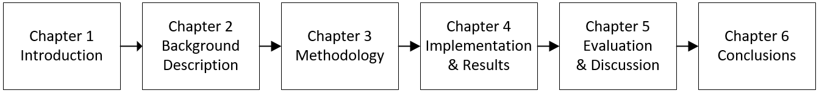

Figure 1.0‑2: Structure of the Thesis

**Chapter 1** introduces about thesis including tools and techniques that we base on to make this project, why we need this application, and what problem it can solve in real life.

**Chapter 2** describes related techniques that my application has to use and gives detail information about some existing Document Digitization applications. Besides, it also shows the advantages and disadvantages of the application.

**Chapter 3** focuses on my method and its description in detail that helps to explain what the user can do in this application and the functions it can support.

**Chapter 4** shows all the functions that have been implemented in the project. It includes some pictures to display the application results.

**Chapter 5** includes the evaluation and discussion of the final result we get from the previous chapter.

**Chapter 6** is the summary of all processes in the thesis. What we have learned to the end of the project, which experiences while the project has been developed. The work we should do in the future to improve the application more effectively.

# CHAPTER 2

# BACKGROUND DESCRIPTION



## NodeJS and Express [1]

NodeJS is an open-source server environment that can run on various platforms such as Windows, Linux, macOS... This environment includes everything we need to execute a program written in Javascript.

The existence of NodeJS makes something that only works on the browser becomes a standalone application thanks to Chrome’s V8 Javascript runtime engine [2], which can convert Javascript into machine code.

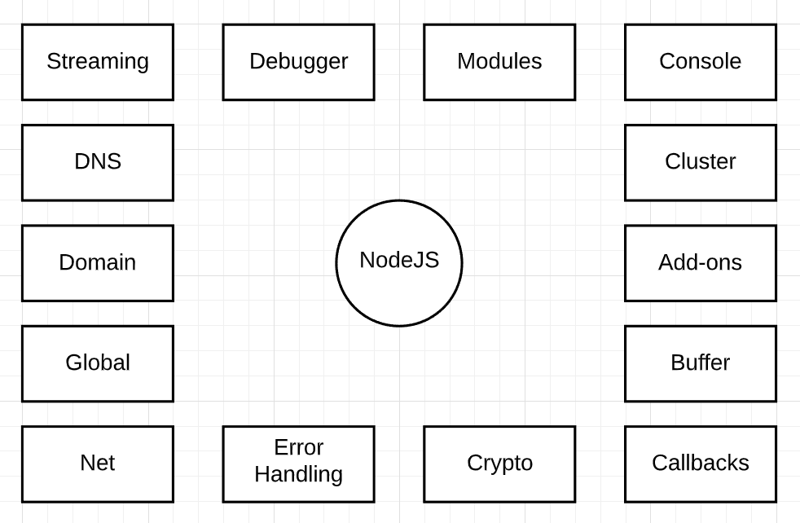

Figure 2.0‑1: The concept of NodeJS

NodeJS has some important features that help it become the first choice of software architects:

* Highly performance
* Asynchronous and Event-Driven
* Single thread with Highly Scalable
* No Buffering
* License

Express is a flexible web application framework of NodeJS which gives robust features for use of the web as well as mobile applications. Express can be used to set up middlewares to respond to HTTP Requests and defines a routing table that is used to perform different actions based on HTTP Method and URL. It also allows us to dynamically render HTML Pages based on passing arguments to templates.

## ReactJS [3]

ReactJS is an open-source JavaScript library that is used for building user interfaces specifically for single-page applications. React was created by Jordan Walke, a software engineer working for Facebook and it’s first deployed on Facebook’s newsfeed in 2011 and on Instagram.com in 2012.

React allows developers to create large web applications that can change data, without reloading the page. The main purpose of React is to be fast, scalable, and simple. It works only on user interfaces in the application. This corresponds to the view in the MVC template. It can be used with a combination of other JavaScript libraries or frameworks, such as AngularJS in MVC.

## MongoDB [4]

MongoDB came into light around the mid-2000s and it is an open-source NoSQL database used for high volume data storage.

It is designed in an object-oriented manner, the tables in MongoDB are the very flexible structure, allowing the data stored on the table does not need to follow a certain structure at all (this is suitable for making big data). MongoDB stores data in the direction of the document, the data is stored in the JSON-style document so the query will be very fast.

Advantages of MongoDB:

* + Flexible schema: Each collection will have different sizes and documents
  + Clear object structure: Although the structure of the data is flexible, its object is clearly defined
  + Using internal memory: the query will be very fast
  + Easy to expand
  + No joins: Contributes to a very fast query speed on MongoDB

MongoDB is suitable for realtime applications.

## Docx library [5]

Docx is a library that has modules to create, read, and write DOC files. These are referred to as ‘WordML’, ‘Office Open XML’, and ‘Open XML’ by Microsoft. They also [validate as well-formed XML](http://validator.w3.org/check).

DocxJS can easily generate a DOC file with JS/TS that works for node and on the browser.

## OpenCV [6]

OpenCV (Open Source Computer Vision) is considered one of the leading open-source libraries for image processing.

OpenCV officially launched in 1999 and it is free for both academic and commercial use. It supports multiple platforms including Windows, Linux, macOS, iOS, and Android with many programming languages like C/C++, Python, Java, and Javascript.

OpenCV is written in C/C++ and integrates OpenCL, so it has good performance that can be used with real-time related applications.

The library has more than 2500 optimized algorithms, most of them have contributed to developing many fields such as:

* Photo recognition
* Image processing
* Recover photos / videos
* Virtual reality
* Other applications

In this thesis, we will use some of its powerful processing functions to identify the data area in the image as well as improve the quality of the material to achieve the best results, including: find contours, dilate, and threshold, and Hough circle algorithm.

## Tesseract OCR [7]

Tesseract is an open-source OCR engine. Its development has been sponsored by [Google](https://en.wikipedia.org/wiki/Google). This engine is available for Windows, Linux, and Mac OS X

Tesseract is not supplied with a GUI and can only be executed from the command-line interface. The first version of Tesseract was only able to convert English-language from image to text. But when version 4 has been released, it now can support over 116 languages.

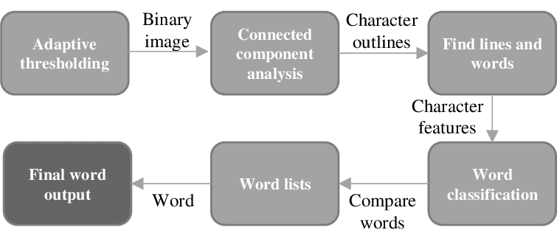

Figure 2.0‑2: Tesseract workflow

To detect and convert the imaged text to string type, Tesseract will try to find and organize text lines into blobs, and the lines and regions are analyzed for fixed proportional text. Base on the kind of character spacing, text lines are split into words. Then, an attempt is made to recognize each word in turn. Each word is passed to an adaptive classifier as training data. This classifier then enhances the accuracy to recognize the text lower down the page. When the adaptive classifier has qualified to contribute to the top of the page, a second pass is run over the page to recognize again the words that were not recognized well enough from the beginning.

Although the newest version of Tesseract has a better performance after adding a new training model with a lot of data and fonts. It’s still not good enough to handle the strange font and handwritten text.

## Existing document digitization application

VietOCR is a GUI frontend for the Tesseract OCR engine. This program can recognize text from images of common formats. It can also function as a console application, which can be executed from the command line[8].

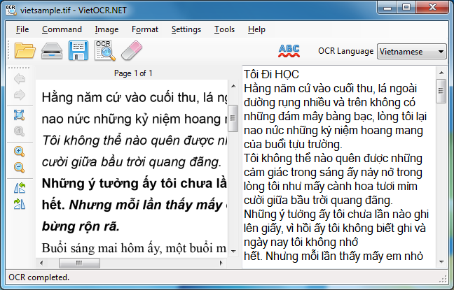

Figure 2.0‑3: VietOCR Interface

VietOCR supports several languages, including Vietnamese. The Vietnamese are trained with Arial, Times New Roman, Courier New, and Verdana fonts. Therefore, images having similar font glyphs can be recognized with a better success rate. OCRing images that have font glyphs look different from the supported fonts generally will require training Tesseract to create another language data pack specifically for those typefaces. This application also provides a tool to merge several images into a single PDF file for convenient OCR operations or to split a PDF file into smaller ones if it is too large, which can cause out-of-memory exceptions.

* Advantage:
  + - Support multiple languages
    - High performance
* Disadvantage:
  + - Components in the document cannot be recognized
    - No data storage and management after the conversion.

# CHAPTER 3

# METHODOLOGY



## Overview

In this chapter, the method applied to the project will be shown. The first part will present the idea that will be used to solve the problem of this thesis. The next part provides information on system architecture. Finally, the database model, user interface, several activities, and sequence diagrams will be shown in the last part.

## Proposed method for the conversion process

In this part, we research on a method that can be used to convert the imaged document into digital format.

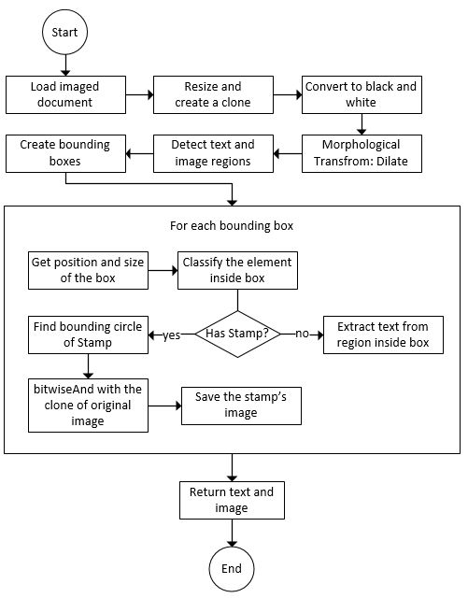

Figure 0‑1: Conversion workflow

After receiving and loading imaged documents for the conversion process:

Firstly, we need to clone this original image for later use, then we convert original images into grayscale images, combined with threshold function to filter out noise elements[9]. Understandably, the threshold process is to change the value of the pixels, if the pixel value exceeds the threshold value, it is assigned the value 1 (white), otherwise, it will be set to 0 (black).

Secondly, to be able to identify each component of the document in the image, we need to fill in the spaces between the characters to form a uniform partition (Using the dilate method increases the character thickness to a specific level).

Then, we identify 4 points of the rectangular area surrounding partitions by finding the contours. [10]

From the four inferred points x, y coordinates and partition size (width, height), from which we can guess the location of the partition corresponding to which components in the image (that can be organization, id, place and date, document type, abstract, content, recipient, position, stamp, or name). If the found component is a stamp, we need to use Hough Circle Algorithm to find the exact circle shape which is the border of the stamp, and save it as an PNG image and will not be used to extract the text.

Finally, we cut each component out of the clone imaged document (having in the first step) and save it as a set of images with the name of the role of that component, the purpose is to easily handle each component individually and at the same time take full advantage of the multithreading.

The psuedo-code for the conversion process operates as follows:

//Conversion

Input: Image file (png/jpg)

Output: Image file (png)

Text

Method:

Step 1: Read image file

Step 2: Resize image with fixed width and height

Step 3: Convert image into pure Black and White using threshold

Step 4: Dilate character in image

Step 6: Find contours in image and save it in variable contours

Step 7: Initialize i = 0

Step 8: While i < contours.length:

Create bounding rectangle with contours[i]

Classify the component inside rectangle

If component = = stamp:

Find bounding circle

Bounding circle bitwiseAnd with image’s clone

Save image in local storage

Else:

Extract text from region inside box

i++

Step 9: Return stamp’s image and text

## System architecture

Model-View-Controller is one of the most popular architectures for applications. As with a lot of other cool things in computer history, the MVC model was conceived as a solution to the problem of organizing applications with graphical user interfaces. It was created for desktop applications, but since then, the idea has been adapted to other mediums including the Web. [11]

The MVC architecture can be briefly described in the figure below:

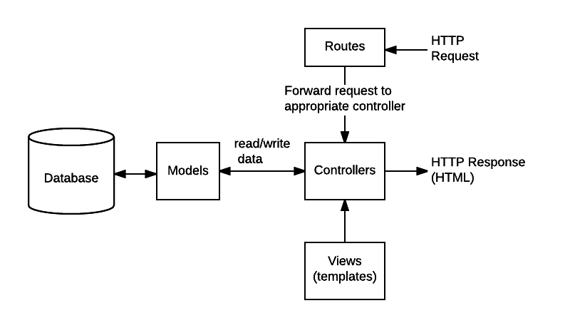

Figure 3.0‑2: System structure

* Models: the part of our application that will deal with the database or any data-related functionality.
* Views: everything the user will see. Basically, the pages that we’re going to send to the client (in this thesis, the view components will be created using ReactJS)
* Controllers: the logic of our site, and the glue between models and views. Here we call our models to get the data, then we put that data on our views to be sent to the users
* Routes: have main function to navigate to a specific Controller which follows a request from the user

## User requirement analysis

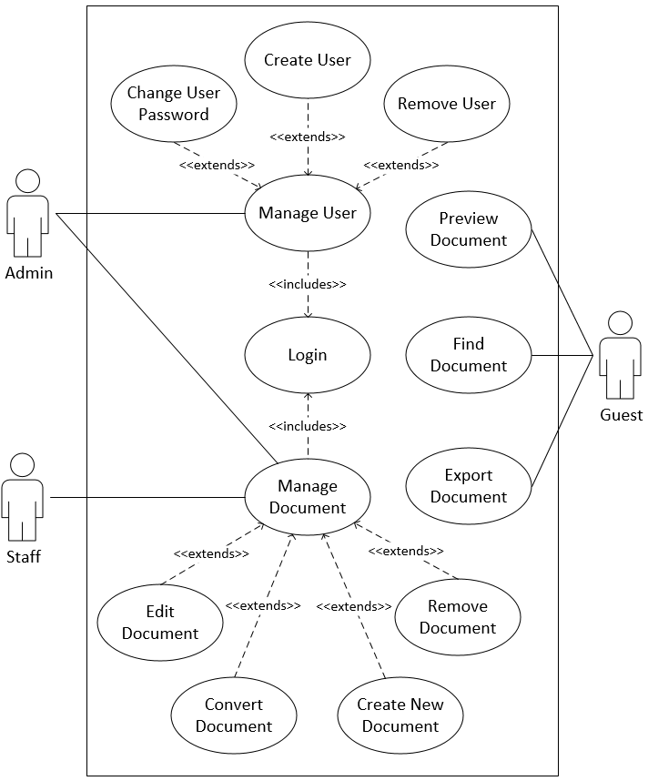

Figure 3.0‑3: Use case diagram

|  |  |
| --- | --- |
| **Name** | **UC-1: Create New Document** |
| Summary | Create a new digital document |
| Rationale | As a user, I want to create a new document that doesn’t exist in both paper form and digital form |
| Users | Admin, Staff |
| Events | 1. Click the Create button 2. In the Create Page, enter all the required information for the document 3. Click the Save button |
| Precondition | None |
| Post conditions | None |

Table 3.1: Use case description for UC-1: Create New Document

|  |  |
| --- | --- |
| **Name** | **UC-2: Convert Document** |
| Summary | Create a digital document from an imaged document |
| Rationale | As a user, I want to convert a paper document into a digital document |
| Users | Admin, Staff |
| Events | 1. Click the Create button 2. In the Create Page, click the Open Image button 3. Select imaged document 4. Select the component (all components in document, id, title...) to convert 5. Locate the document area in the image 6. Click the Convert button 7. After the conversion process, click the Save button |
| Precondition | Image file (jpg, png) of document |
| Post conditions | None |

Table 3.2: Use case description for UC-2: Convert Document

|  |  |
| --- | --- |
| **Name** | **UC-3: Edit Document** |
| Summary | Modify the information of a digital document |
| Rationale | As a user, I want to fix the errors getting from the creation process |
| Users | Admin, Staff |
| Events | 1. Access Database page 2. Click the row of the document that is needed to modify 3. Click the Edit button 4. Modify the document 5. Click the Save button |
| Precondition | Documents and images have been loaded from the database |
| Post conditions | None |

Table 3.3: Use case description for UC-3: Edit Document

|  |  |
| --- | --- |
| **Name** | **UC-4: Remove Document** |
| Summary | Remove the document from the database |
| Rationale | As a user, I want to delete the document that no longer used |
| Users | Admin, Staff |
| Events | 1. Access Database page 2. Click the row of the document that is needed to delete 3. Click the Edit to enable Remove button 4. Click the Remove button |
| Precondition | Documents and images have been loaded from the database |
| Post conditions | None |

Table 3.4: Use case description for UC-4: Remove Document

|  |  |
| --- | --- |
| **Name** | **UC-5: Find Document** |
| Summary | Find one or a list of documents in the database |
| Rationale | As a user, I want to find the document by providing identifying characteristics |
| Users | All users |
| Events | 1. Access Database page 2. Enter the keyword in the filter 3. Click the table header to sort the column in ascending order or descending order |
| Precondition | Document has been loaded from the database |
| Post conditions | None |

Table 3.5: Use case description for UC-5: Find Document

|  |  |
| --- | --- |
| **Name** | **UC-6: Preview Document** |
| Summary | Open and read the document |
| Rationale | As a user, I want to watch the document in printed form or the original imaged document |
| Users | All users |
| Events | 1. After finding out the document, click the document’s row to open the modal 2. Switch between digital form and image form by clicking the “See in image/digital form” button |
| Precondition | Documents and images have been loaded from the database |
| Post conditions | None |

Table 3.6: Use case description for UC-6: Preview Document

|  |  |
| --- | --- |
| **Name** | **UC-7: Export Document** |
| Summary | Export the document to a DOC file |
| Rationale | As a user, I want to export DOC file so that I can copy or print the document |
| Users | All users |
| Events | 1. Access Database page 2. Click the row of the document that is needed to export 3. Click the Export button |
| Precondition | Documents and images have been loaded from the database |
| Post conditions | None |

Table 3.7: Use case description for UC-7: Export Document

|  |  |
| --- | --- |
| **Name** | **UC-8: Create User** |
| Summary | Add a new user to the database |
| Rationale | As a user, I want to create a new user account that can handle a specific function |
| Users | Admin |
| Events | 1. Access User Management page 2. Enter the information of the user in the text fields 3. Click the Create button |
| Precondition | None |
| Post conditions | None |

Table 3.8: Use case description for UC-8: Create User

|  |  |
| --- | --- |
| **Name** | **UC-9: Change User Password** |
| Summary | Change a user password with another password |
| Rationale | As a user, I want to change the password of the existing user |
| Users | Admin |
| Events | 1. Access User Management page 2. Click the Edit button in the row of the user that is needed to change password 3. Enter the new password 4. Click the Save button |
| Precondition | User list has been loaded from the database |
| Post conditions | None |

Table 3.9: Use case description for UC-9: Change User Password

|  |  |
| --- | --- |
| **Name** | **UC-10: Remove User** |
| Summary | Remove a user from the database |
| Rationale | As a user, I want to remove a user account that is no longer used |
| Users | Admin |
| Events | 1. Access User Management page 2. Click the Remove button in the row of the user that is needed to eliminate |
| Precondition | User list has been loaded from the database |
| Post conditions | None |

Table 3.10: Use case description for UC-10: Remove User

## Front-end

The frontend will be designed using ReactJS, so we just have one HTML file (single page web application) created by 2 hash routes which point to Create Document component and Document Storage component. By showing activity diagrams and sequence diagrams, I will describe how the user can interact with the system through these components.

1. **Create New Document**



Figure 3.0‑4: Activity diagram for Create New Document function

***Description:*** The diagram figure above describes step by step how admin and staff can create a new document.

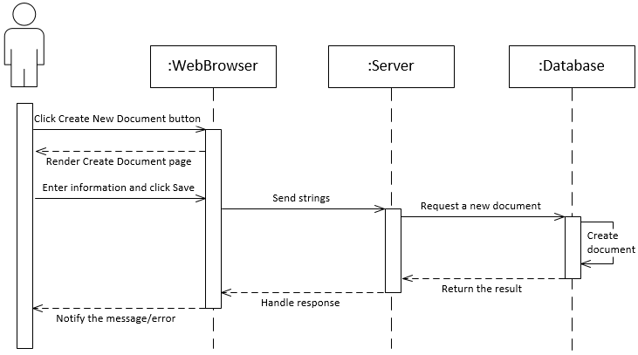

Figure 3.0‑5: Sequence diagram for Create New Document function

***Description:*** When the user goes to the Database page, he or she can access the Create New Document page by clicking the Create New Document button, so that the react component “Create Page” can be rendered in the web browser. Then, the server will receive the providing information about the document from the user and request the MongoDB server to create a new one.

1. **Convert Document**

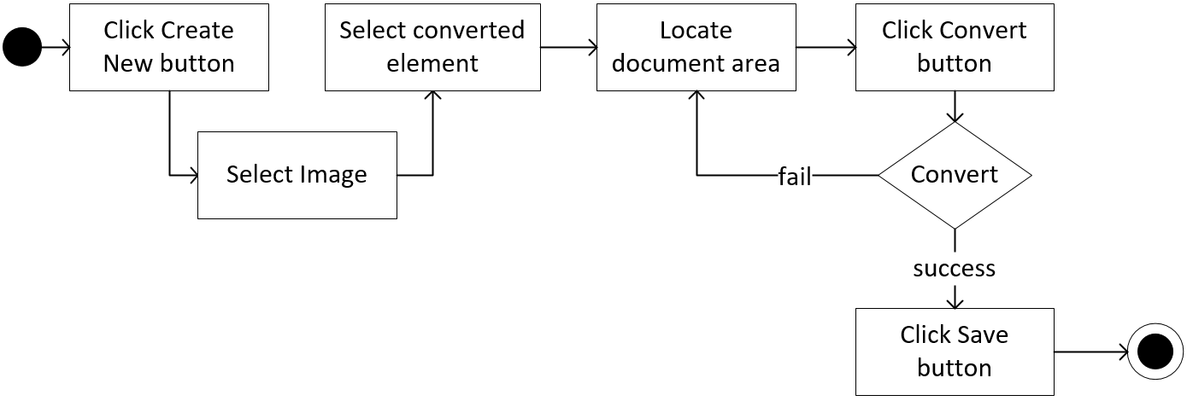

Figure 3.0‑6: Activity diagram for Convert Document function

***Description:*** The diagram figure above describes step by step how admin and staff can do the conversion process to create a new document.

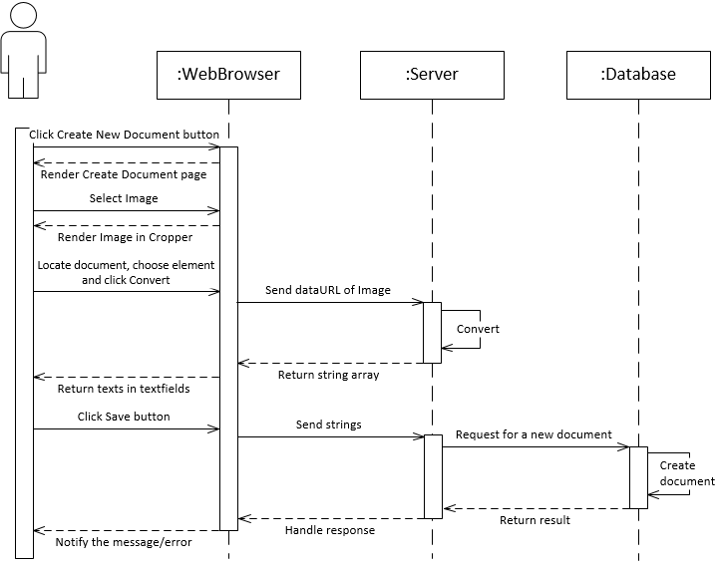

Figure 3.0‑7: Sequence diagram for Convert Document function

***Description:*** When the user accesses the Database page, he or she needs to click the Create New Document button to access Create New Document page, the react-component “Create Page” will be rendered. After that, the user chooses the imaged document from the local storage. Then, they need to select the component to be converted and adjust the cropper box to locate the area of the document in the image. Then, when the user clicks the Convert button, the image will be sent to the server to handle the conversion process and return the string array. Finally, the user checks the result and clicks the save button to ask the server for creating a new document in MongoDB server.

1. **Find**

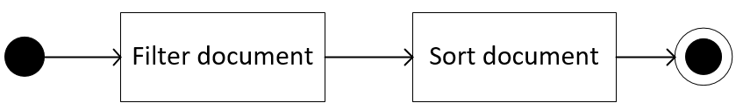

Figure 3.0‑8: Activity diagram for Find function

***Description:*** The diagram figure above describes step by step how the user can find the document.

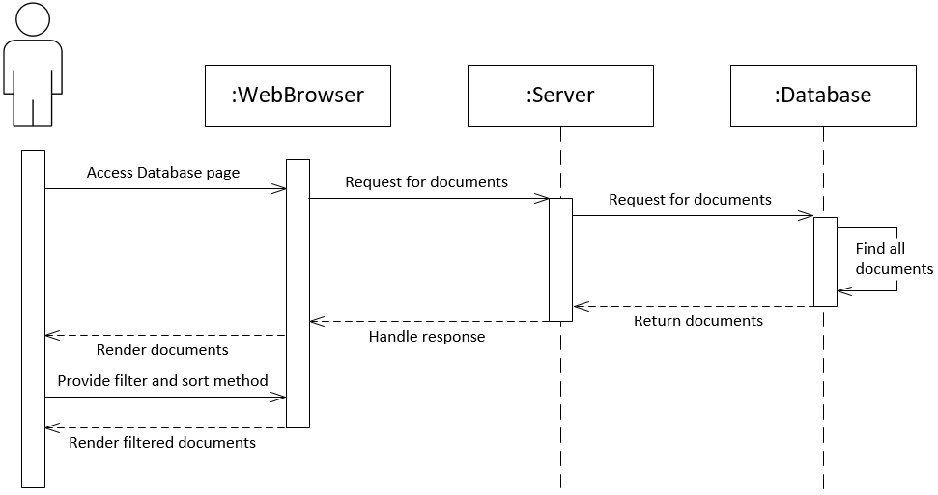

Figure 3.0‑9: Sequence diagram for Find function

***Description:*** After accessing the Database page, a request will be sent to the server to ask for getting the list of documents, which is used to render on the page. When the documents are rendered, the user provides document identification such as keywords and date time to help the filter eliminates irrelevant documents. Finally, the user has a list of documents they want.

1. **Preview**

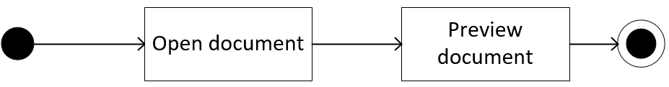

Figure 3.0‑10: Activity diagram for Preview function

***Description:*** The diagram figure above describes step by step how the user can preview the document.

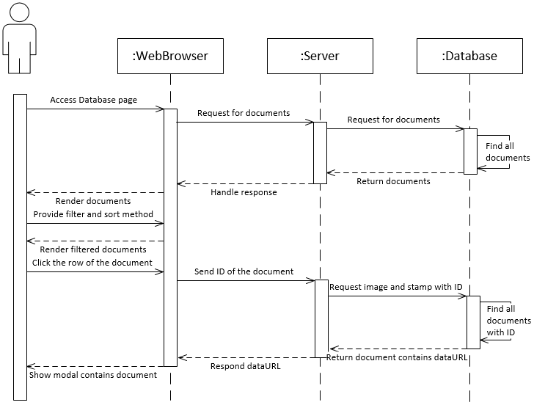

Figure 3.0‑11: Sequence diagram for Preview function

***Description:*** After accessing the Database page, a request will be sent to the server to ask for getting the list of documents and showing it on the page. After that, the user clicks on the row of the document they want to read, so the ID of the document can be sent to the server. The server will seek all image data relate to the ID (image and stamp), then respond to the client, and render all information in the modal.

1. **Edit**



Figure 3.0‑12: Activity diagram for Edit function

***Description:*** The diagram figure above describes step by step how admin or staff can modify the document.

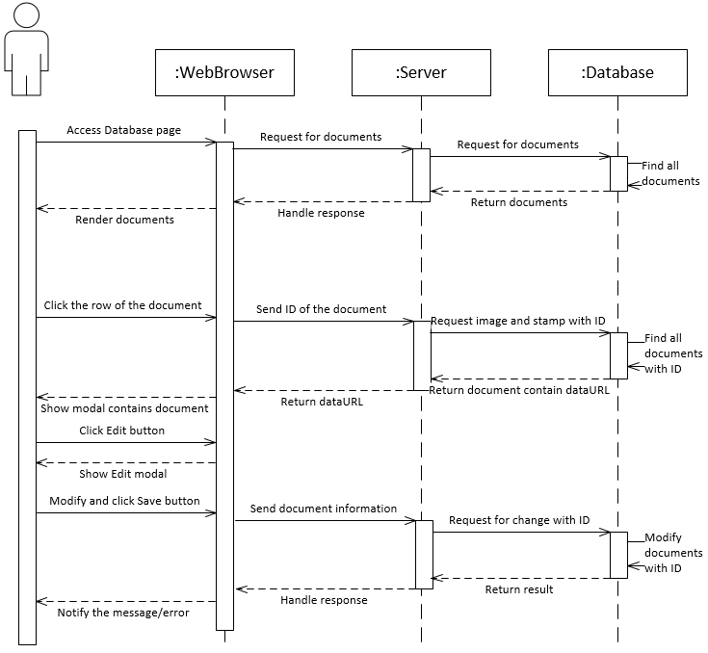

Figure 3.0‑13: Sequence diagram for Edit function

***Description:*** After doing the preview step. The user clicks on the Edit button and get into the edit modal, change the information that needed to modify, then click on the Save button, a request will be sent with the ID asking for changing the document in MongoDB.

1. **Remove**



Figure 3.0‑14: Activity diagram for Remove function

***Description:*** The diagram figure above describes step by step how admin or staff can remove the document.

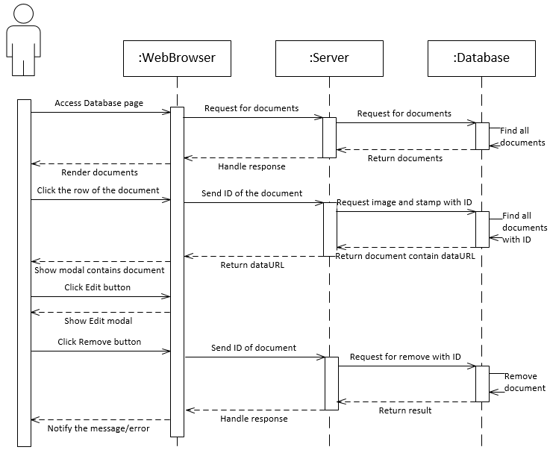

Figure 3.0‑15: Sequence diagram for Remove function

***Description:*** After doing the preview step. The user clicks the Edit button to get into the edit modal, which contains the Remove button, if the user clicks on it, a request will be sent with the ID asking for removing the document in MongoDB.

1. **Export**

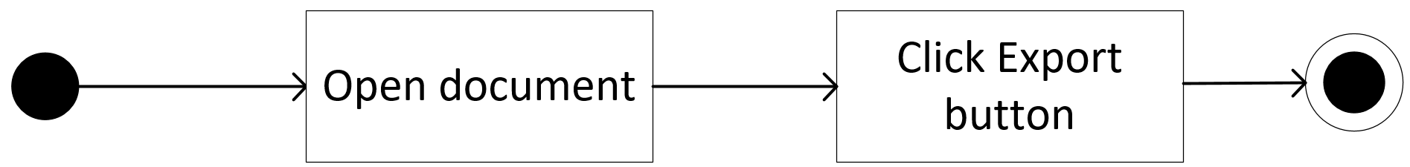

Figure 3.0‑16: Activity diagram for Export function

***Description:*** The diagram figure above describes step by step how the user can export the document.

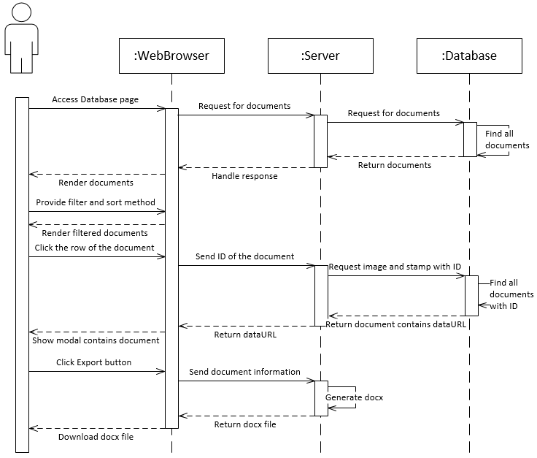

Figure 3.0‑17: Sequence diagram for Export function

***Description:*** After finding and opening the target document, the user can click on the Export button inside the modal, which can trigger the server to pack the document information and send back to the user under the DOC file.

1. **Create User**

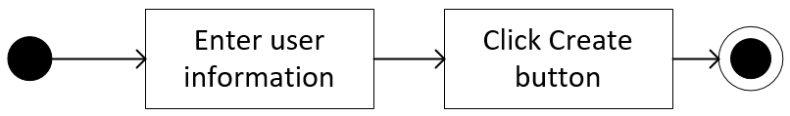

Figure 3.0‑18: Activity diagram for Create User function

***Description:*** The diagram figure above describes step by step how an admin can create a new user account.

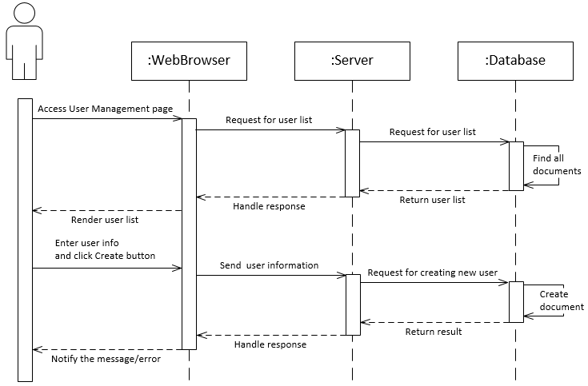

Figure 3.0‑19: Sequence diagram for Create User function

***Description:*** After accessing the User Management page, a request will be sent to the server to asks for getting the list of users and show it on the page. The admin can create a new user by providing username, password, and user permission, then click on the Create button to sent a request to the server asking to create a new user document in MongoDB.

1. **Change User Password**

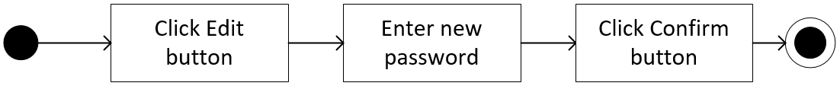

Figure 3.0‑20: Activity diagram for Change User Password function

***Description:*** The diagram figure above describes step by step how an admin can change user password.

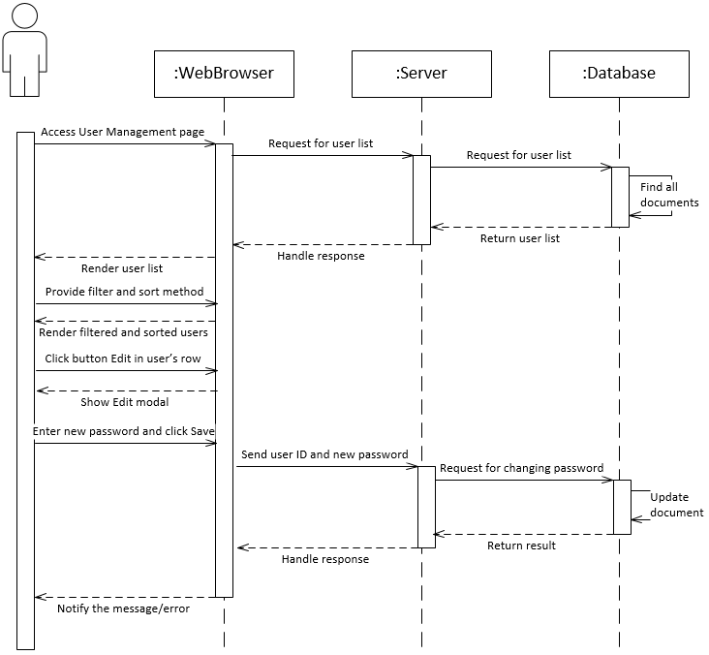

Figure 3.0‑21: Sequence diagram for Change User Password function

***Description:*** After accessing the User Management page, a request will be sent to the server to asks for getting the list of users and show it on the page. The admin can change the user’s password by clicking the Edit button inside the user’s row, typing a new password into the input attribute inside the modal and click Submit to ask the server for applying a new password to the user.

1. **Remove User**

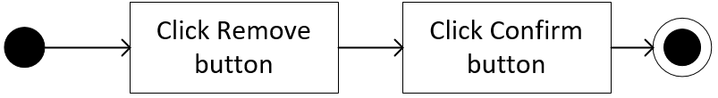

Figure 3.0‑22: Activity diagram for Remove User function

***Description:*** The diagram figure above describes step by step how an admin can remove a user account.

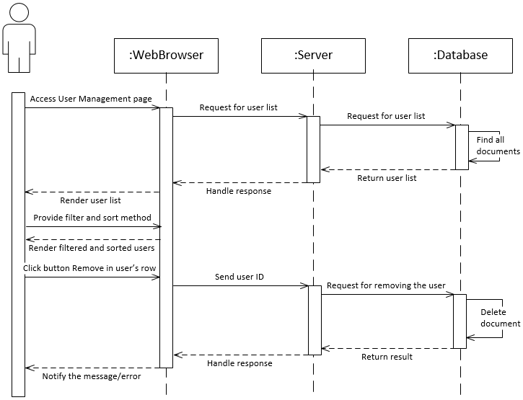

Figure 3.0‑23: Sequence diagram for Remove User function

***Description:*** After accessing the User Management page, a request will be sent to the server to ask for getting the list of users and showing it on the page. The admin removes the user by clicking the Remove button inside the user’s row, a request will be sent to the server to remove the user out of the database.

## System design

### **Database Schema**

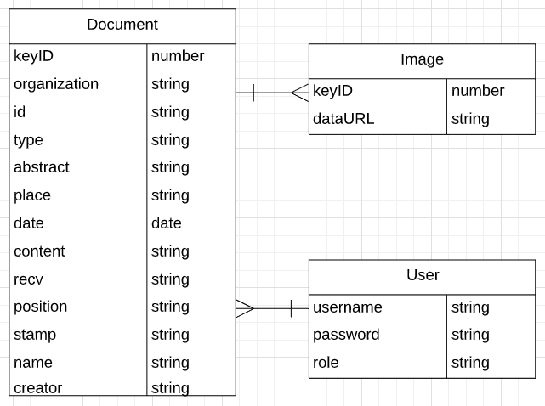

Figure 3.0‑24: Database Schema

* **Document Schema:**
* **keyID:** the ID of the document collection which is unique and required
* **organization:** the name of the organization that writes the document
* **id:** the id of the document
* **type:** the type of the document
* **abstract:** the abstract of the document
* **place:** the place where the document was written
* **date:** the time the document was written
* **content:** the content of the document
* **recv:** the recipient of the document
* **position:** the position of the writer
* **stamp:** the dataURL of the image of the stamp
* **name:** the name of the writer
* **creator:** the username of the account that create this document
* **Image Schema:**
* **keyID:** the ID of the image collection which is unique and required
* **dataURL:** the dataURL of original imaged documents
* **User Schema:**
* **username:** the login name of the user which is unique and required
* **password:** the login password of the user which is required
* **role:** the role reflects the ability to exploit the features of the system which is required

### **Class Diagram**

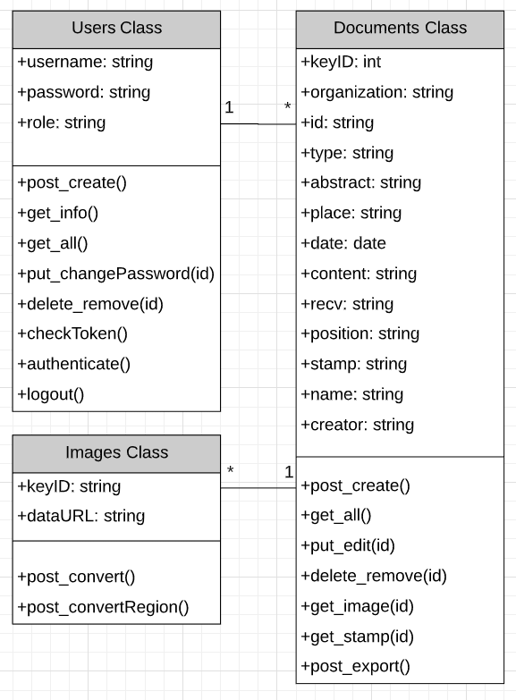

Figure 3.25: Class Diagram

CLASS DIAGRAM DESCRIPTION HERE

### **MVC Model**

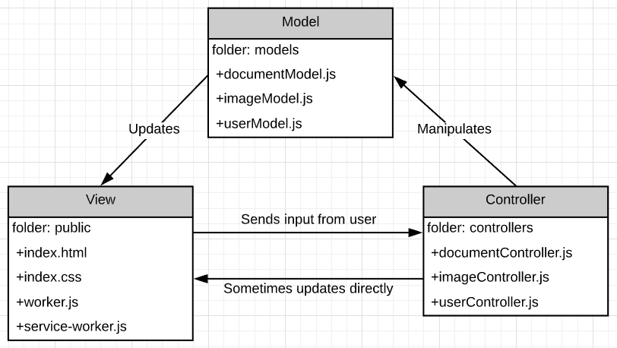

Figure 3.26: MVC Model

### **Graphical user interfaces**

The image below shows a draft user interface I designed for the program:

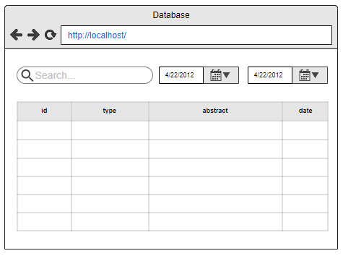

Figure 3.0‑27: User Interface of the Database page

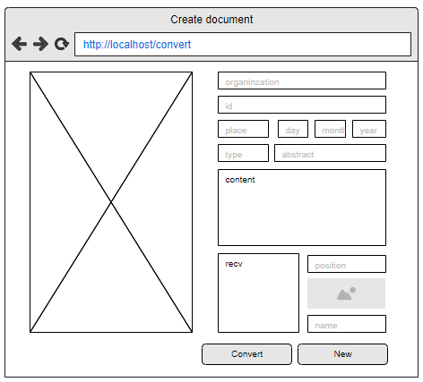

Figure 3.0‑28: User Interface of the Create Document page

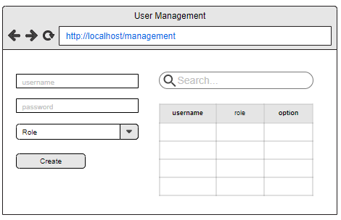

Figure 3.0‑29: User Interface of the User Management page

These are the design of the three main pages. During the development process, we also need to create some support components such as modal and notification to make the interface clear and concise.

# CHAPTER 4

# IMPLEMENTATION AND RESULTS



## Implementation

The system needs to have NodeJS installed. Then, we arrange folders and files following this structure:

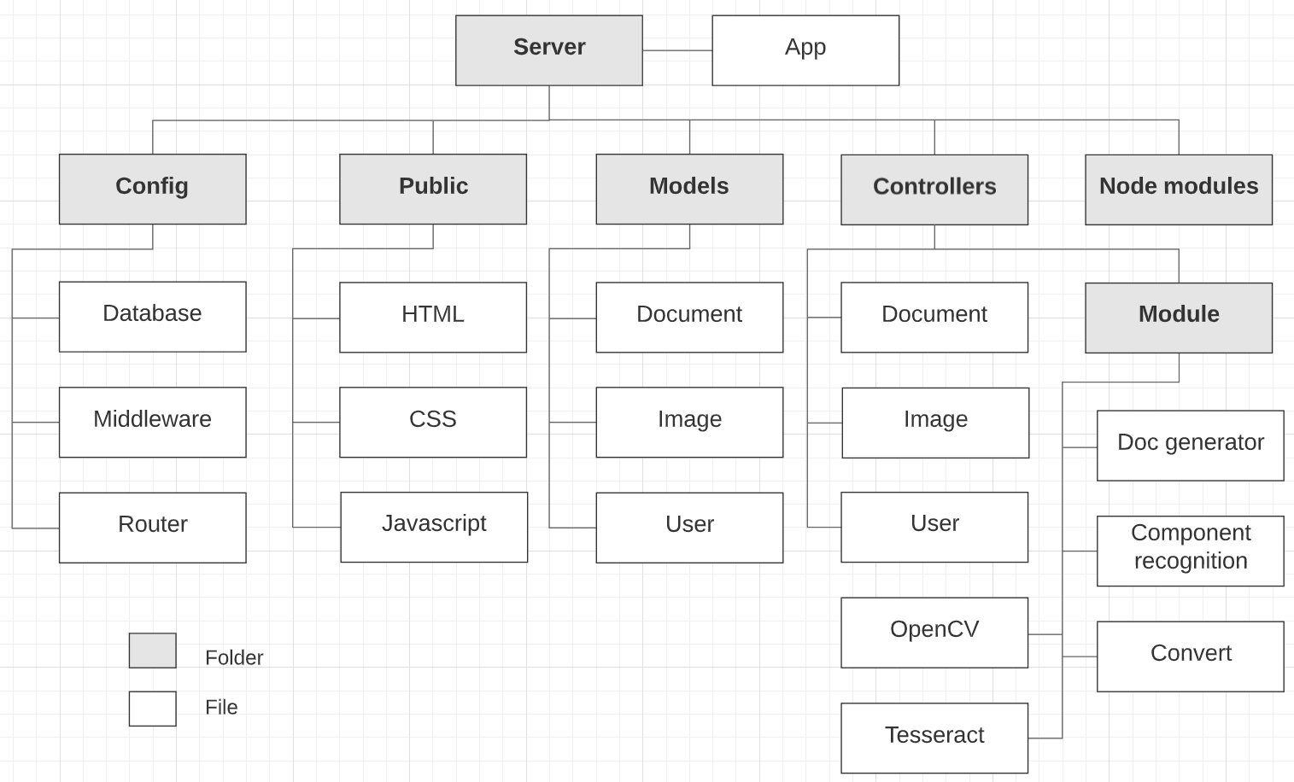

Figure 4.0‑1: Project structure

***Description:***

* + **Config:** The folder contains files that are used to configure the server
    - Database: This is a javascript file that contains code to connect the Node server with the mongoDB database. In this case, the server has already installed in the localhost

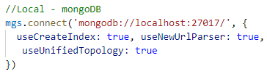

Figure 4.0‑2: Connecting to server

* + - Middleware: This javascript file is used to protect selected routes, and ensure that a user is authenticated (login) before allowing their requests to go through

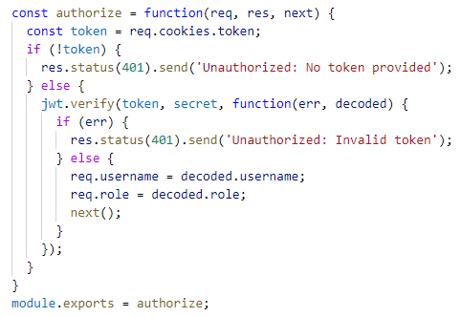

Figure 4.0‑3: Checking the authentication

* + - Routes: have main function to navigate to a specific Controller which follows a request from the user

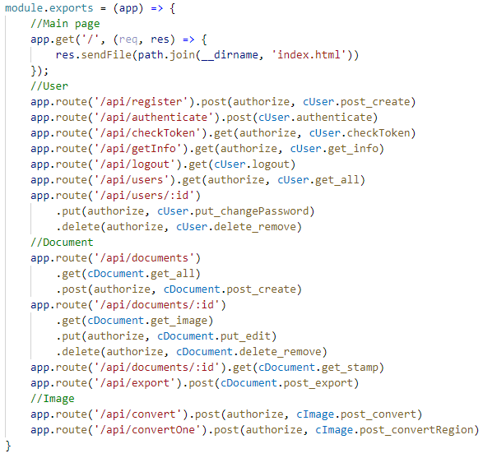

Figure 4.0‑4: Handling the RESTful API

* + **Public:** The folder contains HTML, CSS, and Javascript files that were generated using ReactJS (The result from the front-end development)
  + **Models:** The folder contains javascript files that are used to create mongoDB schemas which define the shape and content in the document collection, image collection, and user collection following section 3.6.1
  + **Controllers:** The folder contains javascript files that have functions to handle requests from the client (such as handling the conversion request, create new user request, edit document request…). These functions will be called inside the Router file
  + **Module:** This folder contains Tesseract trained data, OpenCV.js, and these modules:
    - **components-recognition.js:** the file has javascript code that runs the method from section 3.2
    - **convert.js:** the file has javascript code to configurate TesseractOCR engine to extract text from image.
    - **doc-generator.js:** the file has javascript code to create DOC file using DocxJS library
  + **Node module:** This folder contains all the libraries needed for the server to work. In the first installation, the user needs to type the command "npm install" in the command-line interface to fully update and install the support libraries into this folder
  + **App**: The run file of the server. This is where all the main function executes all the direction of the server

1. **Module component-recognition.js:**

In this module, we rewrite the psuedo-code from the method that has been shown in section 3.2 into javascript language:

**const cv** = require(‘opencv.js’)

**const** **fs** = require(‘fs’)

**let** **oImage** = **cv**.loadImage(IMAGE_PATH)  
 //Load the image file uploaded by the client

**oImage** = **cv**.resize(**oImage**, (WIDTH, HEIGHT)) //Fix original image size

**let** **image** = **cv**.cvtColor(**oImage**, **cv**.RGBA2GRAY) //RGBA to Grayscale

**image** = **cv**.threshold(**image**, cv.THRESH_BINARY_INV) //Grayscale to black and white (binary) only

**image** = **cv**.dilate(**image**, (cv.MORPH_RECT, (15, 10)))   
 //Dilate the text with rectangle-shaped(15x10) kernel

**let** **contours** = **cv**.findContours(**image**)

**let** **i** = 0

**let** **ERR** = 50 //Tolerance = ±50 pixel

**let** **listOfFoundElems** = []

**let** **ElemsProp** = [[‘organization’,x1,y1,w1,h1], [‘id’,x2,y2,w2,h2]...]   
 //x,y,w,h base on component’s position and size

**while** **i** < **contours**:

**let rect** = **cv**.boundingRect(**contours[i]**) //Get bounding rectangle

**for** **elem in** **ElemsProp**:

if(**elem[1]**-**ERR** < **rect**.x < **elem[1]**+**ERR** &&   
 **elem[2]**-**ERR** < **rect**.y < **elem[2]**+**ERR** &&   
 **elem[3]**-**ERR** < **rect**.width < **elem[3]**+**ERR** &&  
 **elem[4]**-**ERR** < **rect**.height < **elem[4]**+**ERR**):

**fs**.writeFile(**elem[0]**+‘.png’, **oImage**.roi(**rect**.x, **rect**.y, **rect**.width, **rect**.height))

**listOfFoundElems**.push(**e[0]**)

break

**i** += 1

**if** **fs**.isExist(‘stamp.png’):

**let** **oStamp** = loadImage(‘stamp.png’)

**oStamp** = **cv**.inRange(**oStamp**, (170,255,255,255), (255,255,255,255))  
 //Get R in RGB color only with 170<R<255

**let** **stamp** = **cv**.cvtColor(**oStamp**, **cv**.RGBA2GRAY)

**stamp** = **cv**.GaussianBlur(**stamp**)

**let** **minR** = 70, **maxR** = 200 //Max, min radius of the circle stamp

**let** **circle** = **cv**.HoughCircles(**stamp**,**cv**.HOUGH_GRADIANT,**minR**,**maxR**)

**let** **mask** = **cv**.circle(**circle**.center,**circle**.radius,(255,255,255,255))

**mask** = **cv**.bitwise_not(**cv**.threshold(**mask**, cv.THRESH_BINARY_INV))

**stamp** = **cv**.bitwise_and(**oStamp**, **stamp**, **mask**)

**fs**.writeFile(‘stamp.png’, **stamp**.roi(**circle**.x,**circle**.y, **circle**.radius*2, **circle**.radius*2)

**return** **listOfFoundElems**

1. **Module convert.js:**

In this module, we will use Tesseract to extract text from each component’s images of the document that we have got from the image process above.

For each individual component, we will use different page segmentation methods (PSM) that Tesseract provides [12]. For example, we will apply PSM 3 (Fully automatic page segmentation) in the configuration to get a text from the Content part, but using PSM 7 (Treat image as a single text line) or PSM 11(Find as much text as possible in no particular order) in the configuration to get a text from the ID part. This will help Tesseract to return a better result.

After converting the images, we will store all of the string in a dictionary type that is easier to manage.

**const tess** = require(‘node-tesseract-ocr’)

**let** **config** = { lang: 'vie', oem: 1, psm: 3 }

**let** **texts** = {}

**for** **elemName** **in listOfFoundElems**

**texts[elemName] =** **tess**.recognize(**element**.png, config)

**return** **texts**

1. **Module doc-generator.js:**

**const** {Packer,Document,Table,Col,Row,Cell,TextRun} = require(‘docx’)

**let** **document** = new Document()

**let** **firstTable** = new Table()

**let** **lastTable** = new Table()

**let** **firstRow** = new Row()

**let** **secondRow** = new Row()Let **lastRow** = new Row() **firstRow**.push(new Cell(new TextRun(**texts[‘Organization’]**)))

**firstRow**.push(new Cell(new TextRun(‘CỘNG HÒA XÃ HỘI CHỦ NGHĨA VIỆT NAM’), new TextRun(‘Độc lập – Tự do – Hạnh phúc’))) **secondRow**.push(new Cell(new TextRun(**texts[‘id’]**)))

**secondRow**.push(new Cell(new TextRun(**texts[‘place’]** + ‘, ngày ’ + **texts[‘day’]** + ‘ tháng ’ + **texts[‘month’]** + ‘ năm ’ + **texts[‘year’]**))) **lastRow**.push(new Cell(new TextRun(**texts[‘recv’]**)))

**lastRow**.push(new Cell(new TextRun(**texts[‘position’]**), new TextRun(‘(Đã ký)’), new TextRun(**texts[‘name’]**))) **firstTable**.push(**firstRow**, **secondRow**) **lastTable**.push(**lastRow**)

**document**.push(**firstTable**, new TextRun(**texts[‘type’]**), new

TextRun(**texts[‘abstract’]**), new TextRun(**texts[‘content’]**), **lastTable**)

**let** **file** = Packer.toBase64String(**document**)

**return** **file**

The real code of this module is also needs some child classes to arrange and set the style for text such as WidthType, BorderStyle, WidthType, Paragraph… But the concept is quite simple as you can see above. This function will be used to describe the system of how to create the docx file with the right document form.

## Results

**Login component**

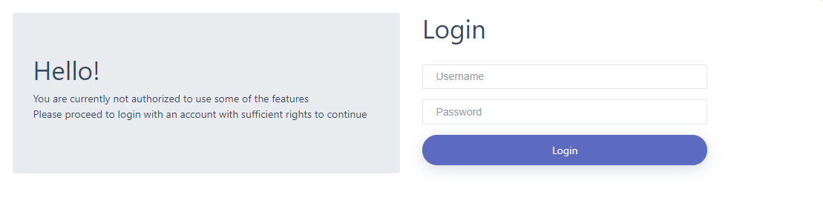

Figure 4.0‑5: Login component

**Create New Document component**

The image below is the user interface when the user runs the application with the browser. In the initial state, we have a blank text area with no imaged document.

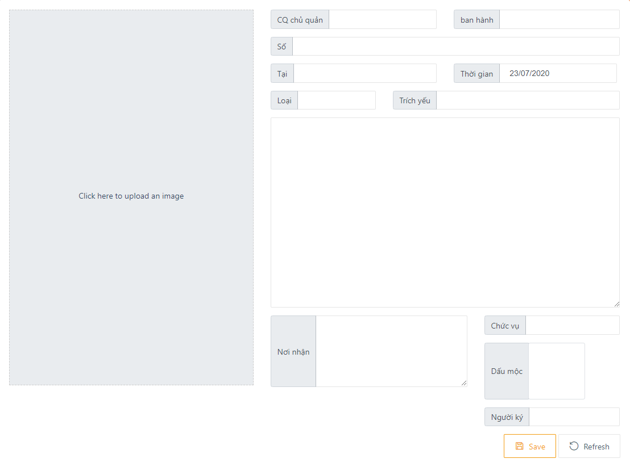

Figure 4.0‑6: Create New Document component

After the conversion process:

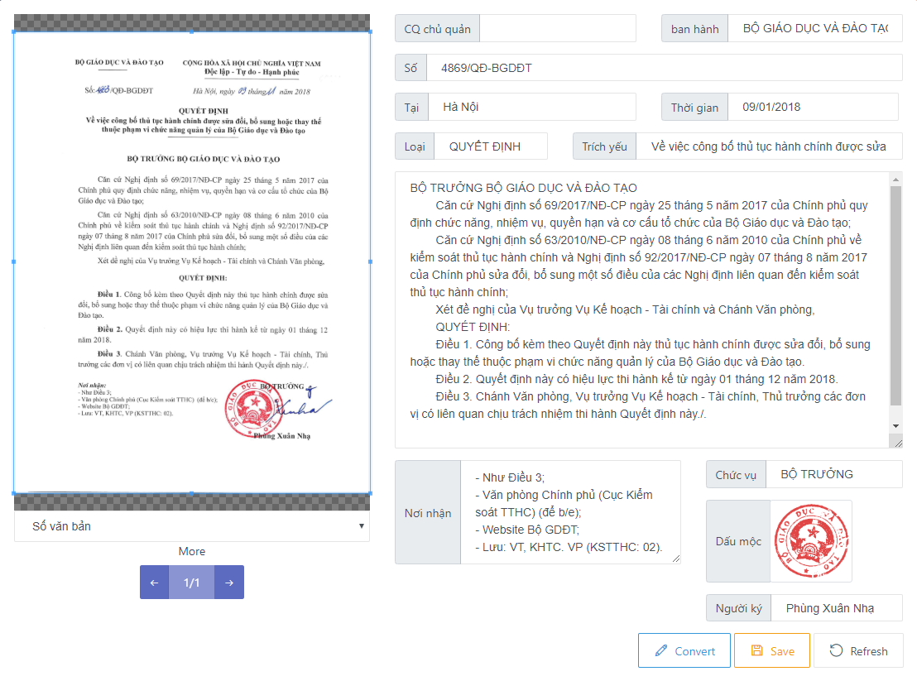

Figure 4.0‑7: Create New Document component after the Conversion process

Confirm after clicking the saving button:



Figure 4.0‑8: Document saving confirm dialog

**User management component**

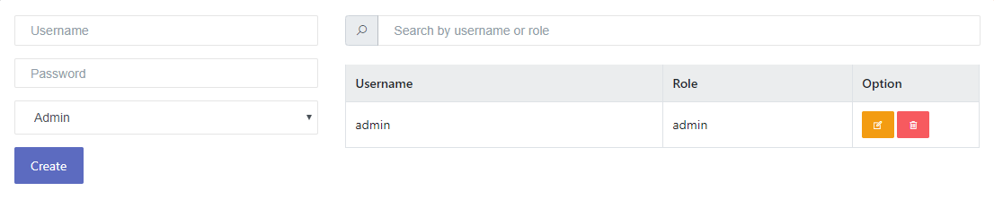

Figure 4.0‑9: User Management component

In this component, the user can create a new account by filling the account’s information in the form on the left side and submit it. Otherwise, the user can change the password, or remove the account by clicking on the option buttons on the right side.

**Database component**

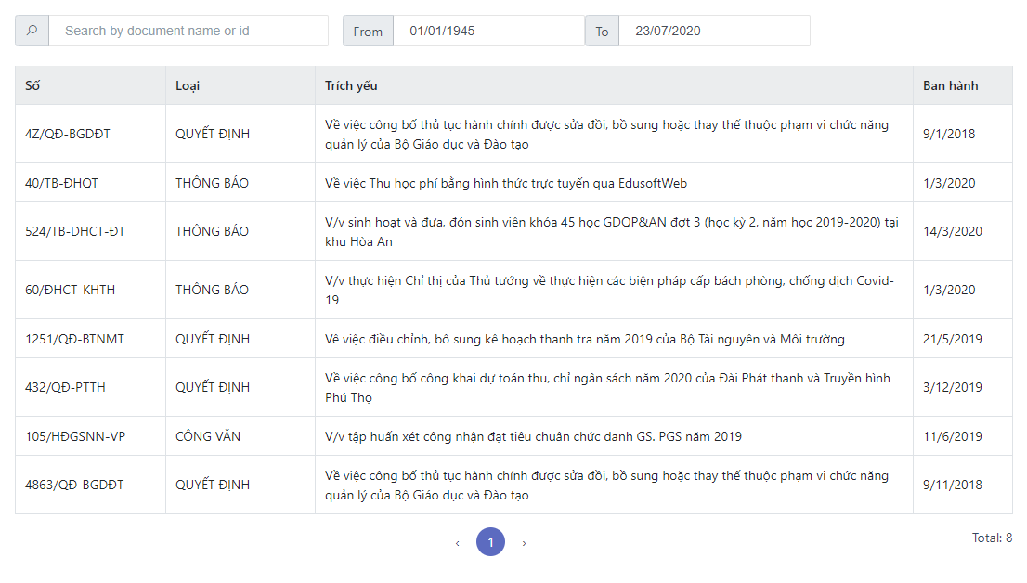

Figure 4.0‑10: Database component

This component has some input to help the user find the document. By clicking on the row of the document we want to read, a modal will popup as the figure below:

**Preview document modal**

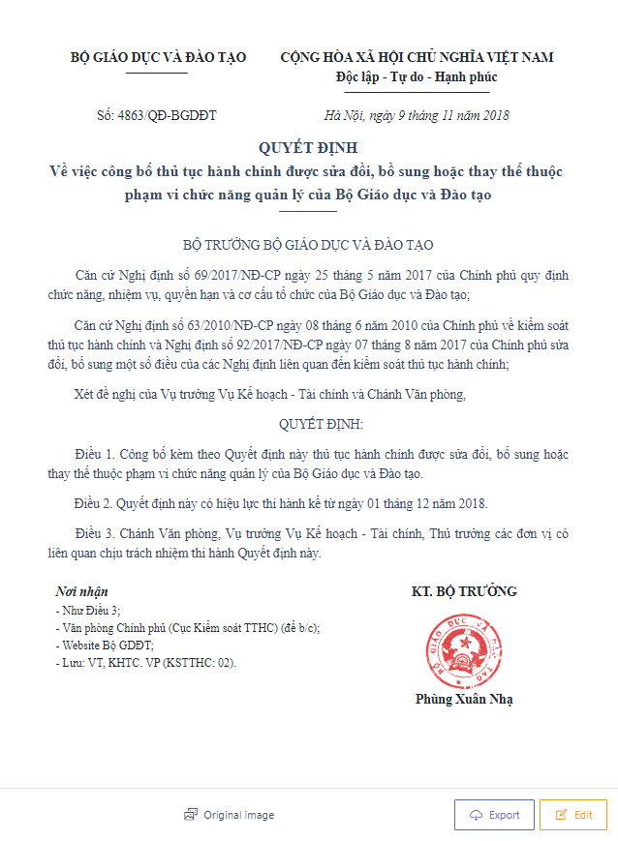

Figure 4.0‑11: Preview modal

In this modal, the user has some buttons which can help them to see the original image of the document, export the document, or edit the document.

**Edit Document modal**

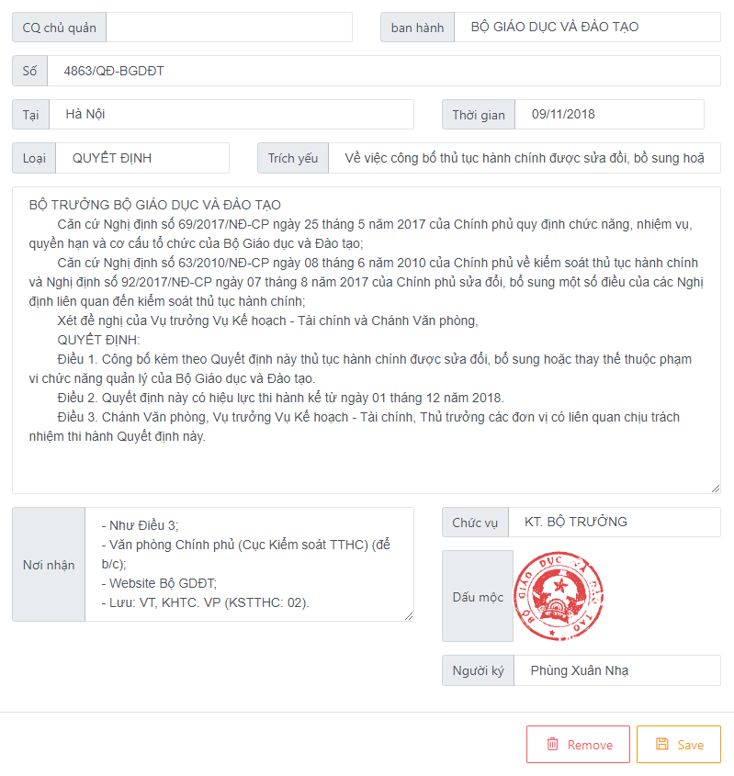

Figure 4.0‑12: Edit modal

In this modal, the user can modify and click the Save button or remove it from the database by clicking on the Remove button.

**An exported file is displayed on Microsoft Word**

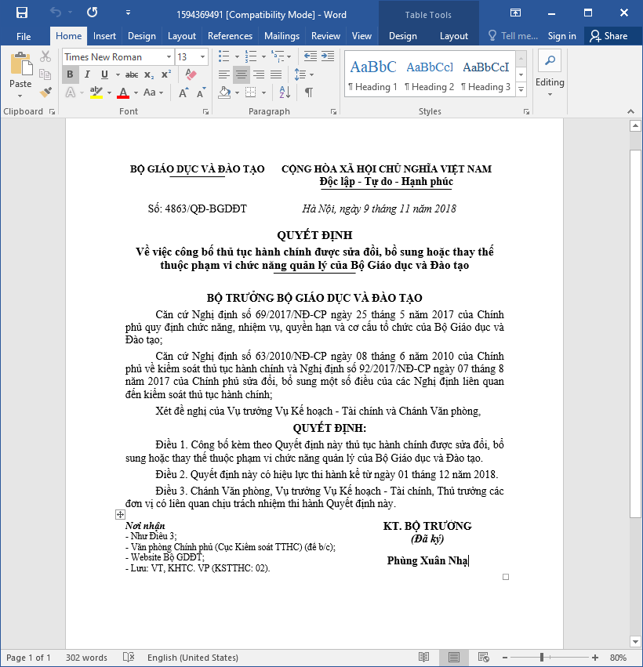

Figure 4.0‑13: An exported DOC file

This is a sample of an exported file that the user can get from the exporting process.

# CHAPTER 5

# EVALUATION AND DISCUSSION

## Evaluation

To evaluate the effectiveness of the application, several tests have been performed. All these tests have been individually analyzed in the scope of optical character recognition and image processing. For the comparison, the overall results on many different document qualities have been presented in table 5.1. Each row in the table represents one experiment performed on a particular document.

The table is composed of these following columns:

* + Document – imaged document that has been used as a sample for testing
  + Quality - refer to the level of accuracy in which different imaging systems capture (high for a scanned image that has DPI over 300, low for an image taken from camera or smartphone)
  + Type – the type of document that has been converted, which can be an image that has been cleaned via image-processing or an original image
  + Character accuracy – the accuracy of the OCR engine recognition on the character level, calculated as follows:



e: the number of character errors  
c: the number of all characters in the document

* Components found – the number of document components that the application find the right place (12 components in total)
* Time – the amount of time to finish the process (including OCR and image denoising)

System specifications for testing:

* CPU: Intel® Core™ i7-8700
* GPU: Nvidia GTX 1070 Ti
* RAM: 8GB 2666MHz

The ID of sample:

* Sample1: 4869/QĐ-BGDĐT
* Sample2: 105/HĐGSNN-VP
* Sample3: 40/TB-ĐHQT

|  |  |  |  |  |  |
| --- | --- | --- | --- | --- | --- |
| Document | Quality | Type | Character accuracy(%) | Components found | Time(s) |
| sample1 | high | original | 95.862 | 10 | 3.104 |
| sample1 | high | cleaned | 98.905 | 12 | 3.467 |
| sample2 | high | original | 97.402 | 11 | 4.494 |
| sample2 | high | cleaned | 98.880 | 12 | 4.839 |
| sample3 | high | original | 95.133 | 11 | 4.195 |
| sample3 | high | cleaned | 96.808 | 12 | 3.954 |
| sample1 | low | original | 88.739 | 11 | 3.024 |
| sample1 | low | cleaned | 89.143 | 11 | 3.101 |
| sample2 | low | original | 86.243 | 10 | 2.726 |
| sample2 | low | cleaned | 87.424 | 11 | 3.080 |
| sample3 | low | original | 79.224 | 9 | 2.879 |
| sample3 | low | cleaned | 82.494 | 10 | 3.276 |

Table 5.12: Accuracy and performance comparison

In general, the “cleaned” type provides more accurate results in terms of character level accuracy, it also gets more correct components position. But the time it takes to finish the process is longer (~300ms).

The accuracy of the high-quality image getting from the scanner overwhelms the low one (>11.62%). So, the better the input, the higher the efficiency.

We can also see that the accuracy with the clean document from scanning is over 95 percent while the additional time is just a little bit. So the trade-off between efficiency and performance is worth it.

For each test, the system will need to provide an average of 500MB of RAM to support OpenCV and Tesseract in image processing and text conversion.

## Discussion

The results of the tests have shown us that the algorithms running in the application are able to meet the requirements of the thesis.

It is possible to digitize documents automatically only by providing a sufficiently powerful system and good quality input. That will greatly assist in reducing administrative workload, reducing manpower, and wasting time.

This web application will be suitable for companies or organizations, where so many documents are stored that they need a new method to handle and manage. Besides, the algorithm used in this application has the potential to develop and apply to many other text digitization models in the future.

# CHAPTER 6

# CONCLUSIONS AND FUTURE WORK



## Conclusions

The objectives of this thesis are researching and implementing an application to convert the paper document into the digitalized document. In this project, we have finished some functions such as image processing using OpenCV, convert the image using Tesseract, fix and preview documents in printed form, saving digitalized documents using mongoDB, as well as exporting the DOC file.

During the time of researching and creating this project, a lot of practical experiences are gained. Firstly, we were able to design a graphical user interface, what we need to do, and what we should not, to make the user approach the program easily. Secondly, it was a good chance to read more about new technology and try some new interesting library, thanks to them, we don’t have to suffer from futile works. Especially, we learned how to schedule and manage the time so that we can catch up on the deadline, which is very useful for the next time when we work in the industry.

## Future work

At the end, we finally created a program that can do some basic functions to convert and get digitalized documents. But still, this project is not finished yet, there are many problems that we need to handle to make the program better. In the future, the method will need to be improved to enhance the accuracy, dealing with handwriting recognization and signature, then optimize the code to make it run faster. Finally, the mobile version is considered to develop if the web application gets good feedback.

# REFERENCES

[1] “Express/Node introduction,” Jun 1, 2020. Accessed on: May 5, 2020 [Online]. Available: <https://developer.mozilla.org/en-US/docs/Learn/Server-side/Express_Nodejs/Introduction>

[2] Mayank Tripathi, “Understanding How the Chrome V8 Engine Translates JavaScript into Machine Code”. Dec 20, 2017. Accessed on: Jun 14, 2020. [Online]. Available: <https://medium.com/free-code-camp/understanding-the-core-of-nodejs-the-powerful-chrome-v8-engine-79e7eb8af964>,

[3] Nitin Pandit, “What and Why React.js”. [Online]. Available:   
<https://www.c-sharpcorner.com/article/what-and-why-reactjs>, Mar 05, 2020

[4] Christudas B, “Install, Configure, and Run MongoDB”, in Practical Microservices Architectural Patterns. Apress, Berkeley, CA, 2019

[5] DocxJS – Getting Started.[Online]. Accessed on: May 24, 2020. Available: <https://docx.js.org/>

[6] Chung B.W. (2017) Getting Started with Processing and OpenCV. In: Pro Processing for Images and Computer Vision with OpenCV. Apress, Berkeley, CA

[7]: Ray Smith, “An Overview of the Tesseract OCR engine” Proc. Ninth Int. Conference on Document Analysis and Recognition (ICDAR), IEEE Computer Society (2007), pp. 629-633

[8] VietOCR – Usage. Accessed on: 10 July, 2020. [Online]. Available: <http://vietocr.sourceforge.net/usage.html>

[9] Fan, L. Zhang, F. Fan, H. et al. Brief review of image denoising techniques. Vis. Comput. Ind. Biomed. Art 2, 7 (2019). <https://doi.org/10.1186/s42492-019-0016-7>

[10] OpenCV – Finding contours in your image. Accessed on: Jun 6, 2020. [Online]. Available:<https://docs.opencv.org/2.4/doc/tutorials/imgproc/shapedescriptors/find_contours/find_contours.html>

[11] J.Kolce, N.Jacques,“How to Build and Structure a Node.js MVC Application”. Accessed on: May 23, 2020.[Online]. Available: https://www.sitepoint.com/node-js-mvc-application, March 23, 2020

[12] Koichi Kise. “Page Segmentation Techniques in Document Analysis,” in *Handbook of Document Image Processing and Recognition.* Springer, 2014, ch. 2, pp. 135-175